 **16 Jan 2015** **The Weekly Bulletin of Rotary Club of Kathmandu Mid-Town** **bc-27/1.015**

|  |
| --- |
|  |

District: 3292 Web:www.rotarymidtown.org.np Club Id: 26776

**JANUARY IS ROTARY AWARENESS MONTH**

Club’s Weekly Meeting # 1261 on Friday, 9 January:

Extracts of the Meeting Minutes are given below:

“1. Meeting No.1261 called to order.

“7. VP HE Rtn Peter Bodde introduced speaker Mina Kaini (US Embassy) who spoke on *'Engaging the Youth'*. Ms Kaini talked about the role she plays to help implement the youth empowerment programme originally envisioned by Hillary Clinton and now carried out by many US embassies throughout the world. The youth programme sponsored by the US Embassy in Kathmandu is advertised by internet only and the youth who apply go through a rigorous selection process for which they need to provide essays, CVs, etc.. In a given year more than 800 applicants apply for some 50 spots. The youth are given opportunities to hone their skills and to apply for small grants which will allow then to start on the path of fulfilling their entrepreneurial or social service dreams. HE Bodde explained that one of the most important skills for young people to learn was the 'elevator speech' i.e. a 45 sec introduction explaining who they are and what they are interested in and why they are approaching the person in the 'elevator'. HE Bodde has been so successful in teaching this skill that he has now taken to using the stairs to avoid supplicants. PP Rtn Ambica gave the vote of thanks.

“8.Information sharing:

> Information on DG's visit next Friday 16 Jan. Please note: the meeting will start at 7:45 AM – this early start will hopefully accommodate all proceedings and still let members get to work on time. The DG's meeting with the Pres,

Sec and PE to go over the Club files will take place on the day before (i.e. Jan 15th). The Chairs need to be ready – to present their reports. The Board decided that since RC Mid-Town is a very mature Club that there was no need to have a Club Assembly on the week before the DG's visit.

> A few words on the recent Rotary Foundation Seminar by PP Komal and PP Mani. Please donate generously to TRF.

> Friendly reminder: 'Rotary South Asia Conference on Peace' during 6-9 February 2015 in Lumbini, the birth place of Lord Gautam Buddha, the ‘Light of Asia’. Rotary International President Gary C.K. Huang will participate in this conference as will other high-level RI dignitaries from throughout Nepal and elsewhere in South Asia. Rotarians donating $500 or more to TRF will be recognized personally by RIP Gary Huang.

> PP William reminded about the 'walking circle' which takes place every Saturday morning – meet at the NTC in Jawalakhel.

> PP Mani informed about the 'zonal meeting' for Zones1-4 to be held on 17 Jan 2015. Please attend if you can.

> Pres Kul presented pins provided by RI to members who had helped to bring in new members recently, namely: PP Ambica (sponsored Ms Sangeeta Enhaus Shrestha*), Pres Kul Chandra (who sponsored and encouraged Rtn Shankar Sharma to rejoin), VP Rtn Lisa Choegyl (sponsored Ms Anja Rasmussen) and Rtn KNS Thapa, (who sponsored Rtn Bhairaja Panday). *Note: Rtn VP Lisa was also involved in encouraging Rtn Sangeeta).

“9. Statistics of the meeting: Members present: 30”.

# Weekly Meetings and Programs :

|  |  |  |
| --- | --- | --- |
| Date | Program/ Speaker | Topic of Presentation |
| 16 January | DG’s Official Visit | Club Assembly |
|  |  |  |
|  |  |  |

Friday, 16 January:



DG’s official visit to the Club:

District Governor Rabindra Piya will conduct the Club Assembly. The respective Chairs of Club

Adminstrationi, Membership Development, Service Projects, The Rotary Foundation, Youth Service

and Public Relations will present their six-month reports, and plans for the remaining six-month of

the year to the District Governor.

The District Governor will provide his comments/observations on the general health of the Club based

on these reports and on the review meeting held on Thursday Jan 15 with President Kul,Gautam,

Secretary Isabella and President-elect Paras.

**South Asia Conference on Peace: 6-9 Feb 2015**

RI District 3292 - Nepal/Bhutan is organising 'Rotary South Asia Conference on Peace' during 6-9 February 2015

in Lumbini, the birth place of Lord Gautam Buddha, the ***Light of Asia***.

The Ministry of Peace and Reconstruction, the Ministry of Culture, Tourism and Civil Aviation and

the Ministry of Cooperatives and Poverty Alleviation are co-organizing this event.

Selected themes for the Conference are:

"Fountain of Peace", "Peace and Conflict Prevention and Resolution",

"Role of UN in Peace Building in South Asia", "Peace and Poverty Alleviation in South Asia",

"Peace and Tourism Development in South Asia", "Youth as Builders of Peace," and

"Role of SAARC on Peace in South Asia"

**The deadline for registration was extended to 15 January 2015**

**Vehicle-Pass:**

If you are already registered and are going to Lumbini on your own car/vehicle for attending South Asia Conference on Peace scheduled to be held at Lumbini Garden 6-9 Feb, you need a vehicle pass to enter the Garden. Else you will be obliged to pay for the entrance ticket each time you go to Garden. Rotary has made arrangement with Lumbini Garden management for issuing the vehicle-pass for the participants’ vehicle/car. In order to avoid entrance ticket hassle at Lumbini Garden, please email your vehicle/car number to [**rotary@ntc.net.np**](mailto:rotary@ntc.net.np)**or** to[**peace2015d3292@gmail.com**](mailto:peace2015d3292@gmail.com) by 15 Jan. Timely emailing will ensure you a vehicle-pass!

The vehicle-pass will be given at Lumbini on ‘First-Come-First-Serve’ basis.

**Matching Grant # 79679 Dhokadi Biogas Project**

First instalment amounting to Rs 500,000 is being processed which will be released soon to contractor Tribeni Gobar Gas Company, Kawasoti, Nawalparasi for construction of biogas plants under the project. The company has agreed to complete construction of the first 10 biogas plants within a period of 30 days of receiving the first payment and will continue construction of the rest of the biogas plants on time.

*Source: Rtn Pavitra Jung Rayamajhi*

**Walking Fellowship: Mid-Town Walking Circle**

Saturday, 10 Jan morning: Mid-Town Walking-Circle members assembled at Jawalakhel.

They drove upto Taudaha and started going up-hills Bosun / Champadevi Paau.

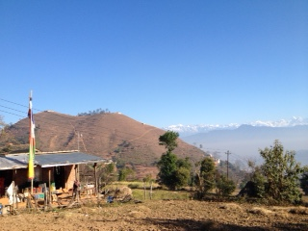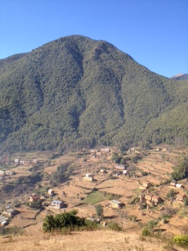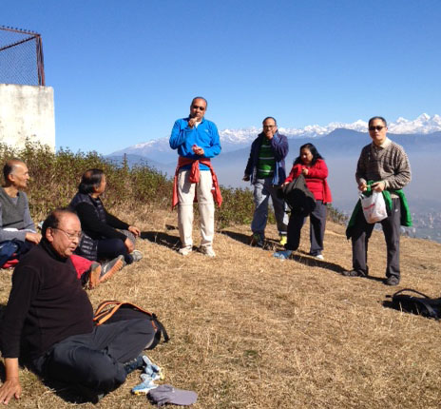

**A THOUGHT FOR TODAY:**

**In religion, faith is a virtue.** **In science, faith is a vice.**

--Jerry Coyne, Biology professor (b. 1949)

*Courtesy: Rtn Isabella Khadka*

Travel / Tourism



“The World Is a Book and Those Who Do Not Travel Read Only One Page”

On Lighter Side:

I talk to myself because I like dealing with a better class of people.

**One day Flying Fighter Jet will be as easy as playing on a game console!**

Could flying a fighter jet really be as easy as playing on a game



console?

Well, one pilot testing the new F-35 Lightning II aircraft

believes that it is easy as playing on a game console. The

fighter jet will be one of the most advanced in the world when

it starts being used by the UK, America and other countries

soon. Pilot Pete Kosogorin said that you press a couple of

buttons and the aircraft will do so much for you. It will slow

down and stop exactly where you like it to. You press a button,

the airplane changes from conventional mode – like a normal

aeroplane – into the short take-off and vertical landing mode,

where the pilot can adjust everything just by light touches on

the controls. *Source: The Himalayan Times*



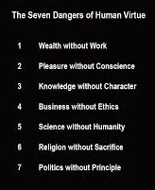

**Horoscope 2015**

AN ACCURATE HOROSCOPE - Don’t ignore it. This is the real deal.

Try ignoring it, and the first thing you’ll notice is having a horrible day starting tomorrow morning, and it only gets worse from there.

As promised in the last BC, the horoscope of the remaining six Zodiac signs – Libra, Scorpio, Sagittarius, Capricorn, Aquarius, and Pisces are given in ‘Annex’

*Source: Rtn Isabella Khadka*

And if you haven't planned a Rotary Day yet, why not? It's a great way to share your love

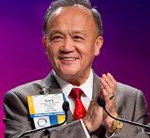

for Rotary with your community. When we tell others about Rotary and let them know how

membership can enrich their lives, we share a gift that was given to us when we were

invited to join our clubs. By passing that gift on, we help ensure that Rotary, and its service,

will endure for generations to come.

**RI President GARY C.K. HUANG**

## 16 January 2015 The Weekly Bulletin of Rotary Club of Kathmandu Mid-Town bc-27/1.015

*******************************

‘Annex’

**Horoscope 2015**

**LIBRA – The Lame One (September 23 to October 22)**  
Nice to everyone they meet. Their love is one of a kind. Silly, funny and sweet. Have own unique appeal. Most caring person you will ever meet! However, not the kind of person you want to mess with… you might end up crying. Libras can cause as much havoc as they can prevent. Faithful friends to the end. Can hold a grudge for years. Libras are someone you want on your side. Usually great at sports and are extreme sports fanatics. Very creative. A hopeless romantic.

9 years of bad luck if you do not share this post.

**SCORPIO – The Addict (October 23 to November 21)**  
EXTREMELY adorable. Loves to joke. Very good sense of humor. Will try almost anything once. Loves to be pampered. Energetic. Predictable. GREAT kisser. Always get what they want. Attractive. Loves being in long relationships. Talkative. Loves to party but at times to the extreme. Loves the smell and feel of money and is good at making it but just as good at spending it! Very protective over loved ones. HARD workers. Can be a good friend but if is disrespected by a friend, the friendship will end. Romantic. Caring.

4 years of bad Luck if you do not share this post.

**SAGITTARIUS – The Promiscuous One (November 22 to December 21)**  
Spontaneous. High appeal. Rare to find. Great when found. Loves being in long relationships. So much love to give. A loner most of the time. Loses patience easily and will not take crap. If in a bad mood stay FAR away. Gets offended easily and remembers the offense forever. Loves deeply but at times will not show it, feels it is a sign of weakness. Has many fears but will not show it. VERY private person. Defends loved ones with all their abilities. Can be childish often. Not one to mess with. Very pretty. Very romantic. Nice to everyone they meet. Their Love is one of a kind. Silly, fun and sweet. Have own unique appeal. Most caring person you will ever meet! Amazing in bed!!! Not the kind of person you want to mess with- you might end up crying.

4 years of bad luck if you do not share this post.

**CAPRICORN – The Passionate Lover (December 22 to January 19)**  
Love to bust. Nice. Sassy. Intelligent. Sexy. Grouchy at times and annoying to some. Lazy and love to take it easy, but when they find a job or something they like to do they put their all into it. Proud, understanding and sweet. Irresistible. Loves being in long relationships. Great talker. Always gets what he or she wants. Cool. Loves to win against other signs in sports, especially Gemini’s. Likes to cook but would rather go out  
To eat at good restaurants. Extremely fun. Loves to joke. Smart.

24 years of bad luck if you do not share this post.

**AQUARIUS – Does It in the Water (January 20 to February 18)**  
Trustworthy. Attractive. Great kisser. One of a kind. Loves being in long-term relationships. Tries hard. Will take on any project. Proud of themselves in whatever they do. Messy and unorganized. Procrastinators. Great lovers, when they’re not sleeping. Extreme thinkers. Loves their pets usually more than their family. Can be VERY irritating to others when they try to explain or tell a story. Unpredictable. Will exceed your expectations. Not a fighter, but will knock your lights out.

2 years of bad luck if you do not share this post.

**PISCES – The Partner for Life (February 19 to March 20)**  
Caring and kind. Smart. Likes to be the center of attention. Very organized. High appeal to opposite sex. Likes to have the last word. Good to find, but hard to keep. Passionate, wonderful lovers. Fun to be around. Too trusting at times and gets hurt easily. VERY caring. They always try to do the right thing and sometimes get the short end of the stick. They sometimes get used by others and get hurt because of their trusting. Extremely weird but in a good way. Good sense of humor!! Thoughtful. Loves to joke. Very popular. Silly, fun and sweet. Good friend to others but needs to be choosy on who they allow their friends to be.

5 years of bad luck if you do not share this post.

